**Combined Tree Ring Anomalies of all locations**

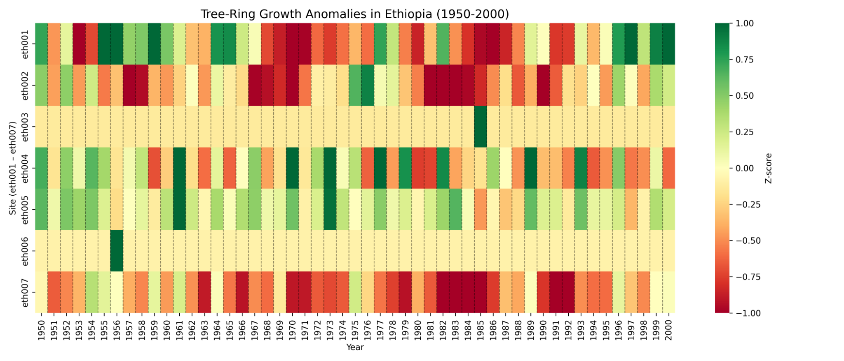

The heatmap summarizes standardized tree-ring growth (Z-score) for seven Ethiopian sampling sites from 1950–2000. Most sites display episodic, synchronous anomalies (deep red or green bands) that indicate periods of strong growth suppression or enhancement. Several of the largest negative anomalies are clustered in the late 1950s, the late 1960s/early 1970s and most prominently the early- to mid-1980s — intervals during which historical records report major droughts and famines in Ethiopia. Importantly, not all sites respond the same way: eth001, eth002, eth004, eth005 and eth007 show clear multi-year negative anomaly clusters, whereas eth003 and eth006 remain close to zero throughout most of the record. This muted response at eth003 and eth006 likely reflects local buffering effects such as higher elevation, favorablemicroclimates, or deeper soil moisture access, which can reducedrought sensitivity compared to other sites [Source](https://academic.oup.com/jpe/article/14/5/829/6209400?).

**Combined Tree Ring Growth of all locations**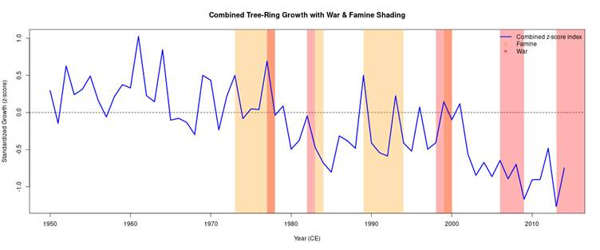

# Historical Climatic & War Events in Ethiopia

The following events in Ethiopian history are well documented and align with periods when tree-ring data is available. For each event we describe what happened, where, causes, and why it should show up in tree-ring data.

1. **1958 Tigray Famine (~1957-1958)**[Link](https://en.wikipedia.org/wiki/1958_Tigray_famine?) In the late 1950s, especially 1957-1958, a severe famine struck Tigray and parts of Wollo provinces during the reign of Emperor Haile Selassie. The triggers included successive droughts, locust invasions, and neglect of agricultural infrastructure. Up to 100,000 people died.

**Possible Relation to tree-rings***:* Because tree growth is sensitive to moisture and season length, this period should show as a negative anomaly in the z-score. The samples include trees from Tigray or nearby highlands with good preservation; we expect a dip in growth around 1957-1958.

2. **1972-1975 Wollo Famine**[Link](https://en.wikipedia.org/wiki/1972%E2%80%931975_Wollo_famine?) Between 1972 and 1975, particularly in Wollo province and surrounding arid highland regions, Ethiopia experienced a prolonged famine. Crop failures due to rainfall deficit, poor governmental response, and socio-economic weakness greatly exacerbated the crisis. Sources estimate the death toll between 40,000-80,000.

**Possible Relation to tree-rings***:* A multi-year depressed growth should likely be visible in this period. Because the drought impact lasted several years, tree rings from 1972-75 should show lower ring widths, possibly a decreased z-score trend.

3. **1983-1985 (1984) Ethiopian Famine**[Link 1](https://www.trocaire.org/sites/default/files/resources/policy/1986-africa-famine-80s.pdf.pdf), [Link 2](https://en.wikipedia.org/wiki/1983%E2%80%931985_famine_in_Ethiopia?) One of the most catastrophic famines in Ethiopia’s recent history affected northern provinces (Tigray, Wollo, Begemder, Eritrea). It was caused by a combination of political instability, civil conflict, failed rains (both Belg and Meher seasons), and other stressors. Estimated death toll ranges from hundreds of thousands up to ~1.2 million.

**Possible Relation to tree-rings***:* Because of the severity and breadth of this famine, one expects very pronounced negative anomalies around 1983-1985. Multiple cores in affected provinces should show growth suppression, negative z-scores.

4. **2015-2016 Drought (El Niño-associated)**[Link](https://www.worldweatherattribution.org/ethiopia-drought-2015/) In 2015, Ethiopia suffered one of its worst droughts in decades. The drought was aggravated by a strong El Niño event. The Belg rains (Feb-May) were delayed or deficient; Kiremt season (June-September) rains were erratic and stopped early. Nearly 10 million people in the north and central regions were severely affected; many farmers lost crops and livestock.

**Possible Relation to tree-rings***:* In trees from central or northern Ethiopia, the years 2015 and 2016 should show negative z-score anomalies if growth was limited by moisture. Growth rings might be narrower. Because this is recent, preservation and dating should be good, giving a clearer signal.

# Relation of These Events to the Z-Score Graph

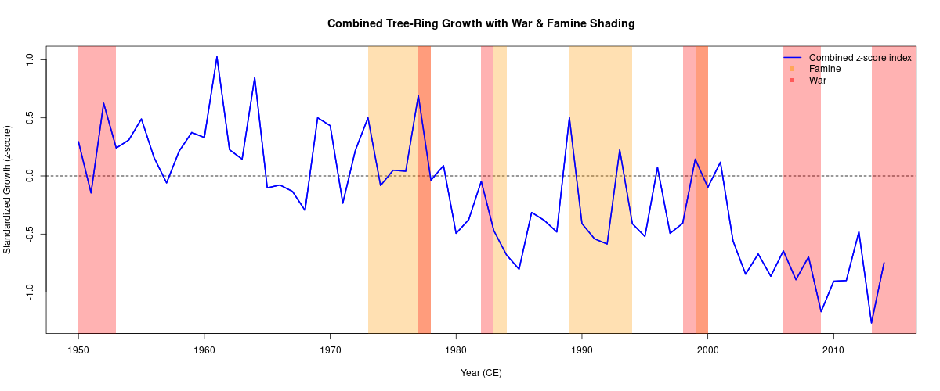

* **~1957-1958**: A drop in growth (negative z-score) aligns with the 1958 Tigray famine. The graph shows a dip here that supports the drought/famine link.

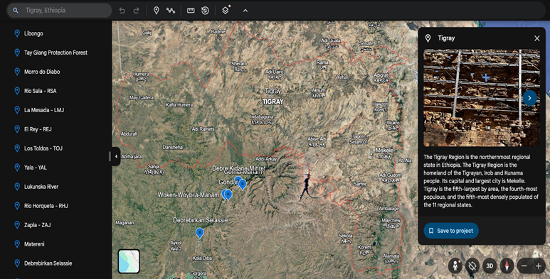

Nearest Data Region: Gomia-Mariam(eth002), Gondar(eth007)

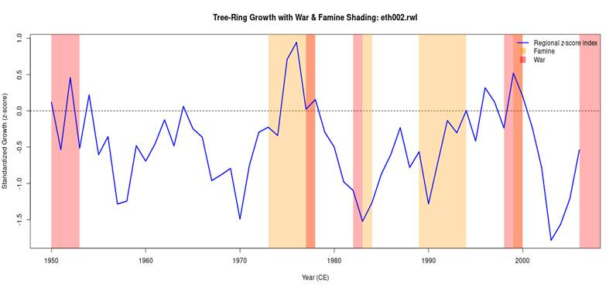

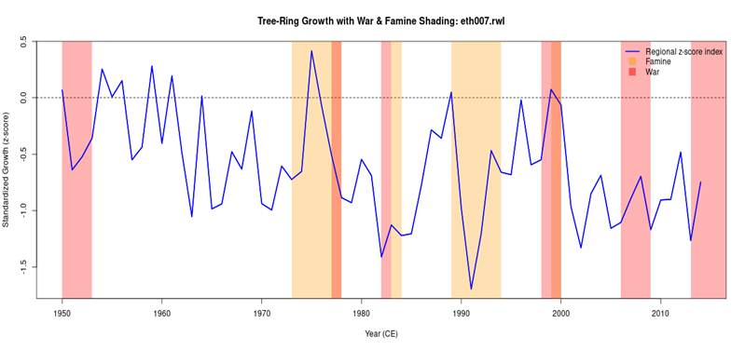

* **Early 1970s (~1972-1975)**: A sustained lower growth or negative trend, matching the Wollo famine period, we see depressed z-scores, specifically in the Wollo Region Data of Tree Rings.

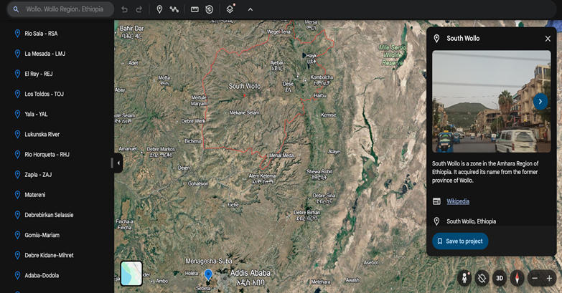

Nearest Data Region: Menagesha Suba (eth005)

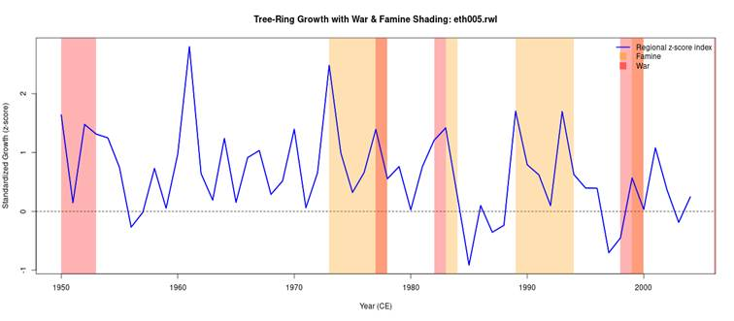

* **Early-Mid 1980s (1983-1985)**: One of the deepest valleys in the graph is during this span. The famine here was severe, so tree-rings should show among the lowest growth values.

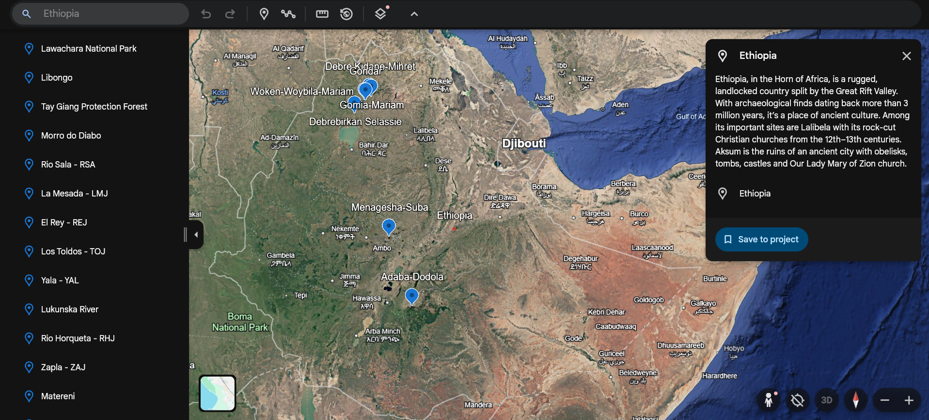

Data Regions: Debrebirkan Selassie (eth001), Mariam(eth002), Debre Kidane-Mihret (eth003), Adaba-Dodola(eth004), Menagesha Suba (eth005), Woken-Woybila-Mariam(eth006), Gondar(eth007)

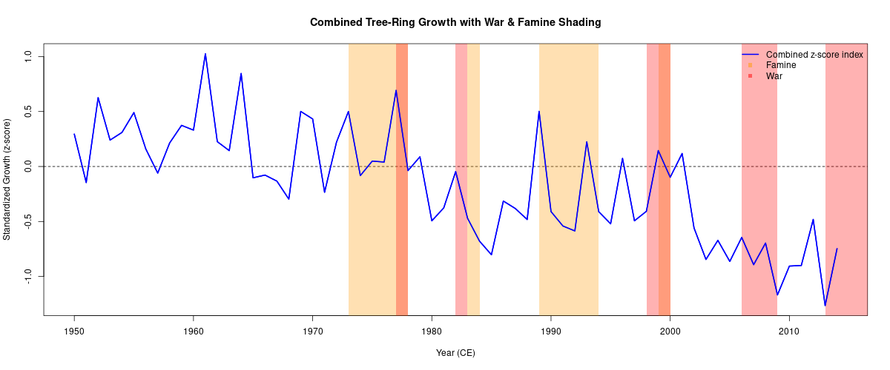

* **2015-2016**: The 2015–2016 interval is marked by a clear negative anomaly: z-scores fall below the long-term mean and constitute one of the more pronounced recent negative excursions in this record. This decline on eth-001 is consistent with suppressed radial growth expected during a strong, El Niño-associated drought (shortened growing season and reduced cambial activity), and therefore indicates moisture-limited growth in those years.

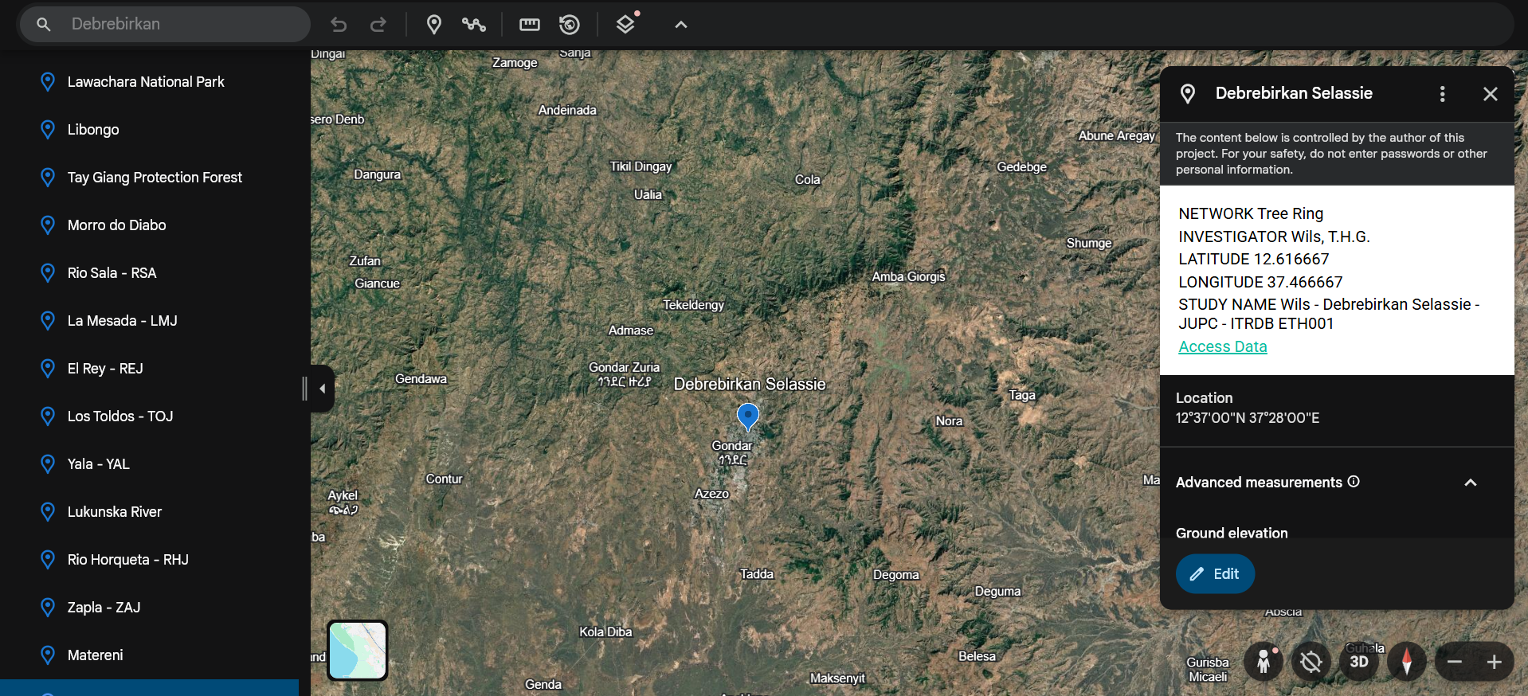

Data Region: Debrebirkan Selassie (eth001)

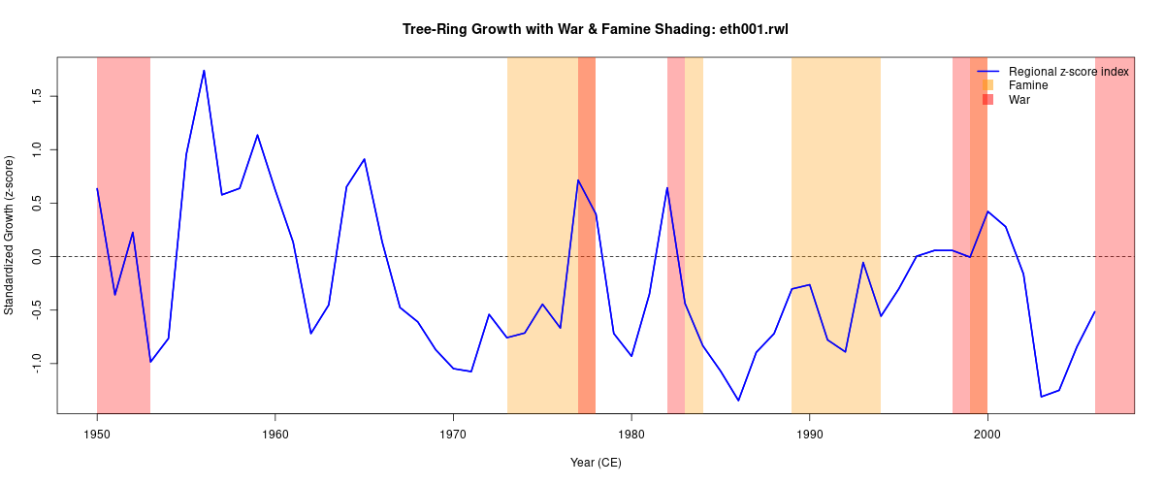

# References

* EMDAT: [EM-DAT - The international disaster database](https://www.emdat.be/#:~:text=)
* OWID: [The Our World in Data Dataset of Famines](https://ourworldindata.org/the-our-world-in-data-dataset-of-famines#:~:text=The%20OWID%20Dataset%20of%20Famines)
* Global high-resolution drought indices for 1981–2022: [Global high-resolution drought indices for 1981–2022](https://essd.copernicus.org/articles/15/5449/2023/essd-15-5449-2023.html)
* War Effects in Ethiopia: [Source](https://www.tandfonline.com/doi/full/10.1080/23311932.2023.2247696?)
* 2015-2016 Drought (El Niño-associated)[Source](https://www.worldweatherattribution.org/ethiopia-drought-2015/)